

“Database Security Using Encryption”

**Technical Writing and Seminar I**

**MCS15**

**MASTER OF TECHNOLOGY**

In

Computer Science and Engineering

Name of the Student: Ashraf Ali S

USN: 1MS18SCS03

Under the guidance of

DR. MOHANA KUMAR S

**Associate Professor**

**Department of Computer Science & Engineering**

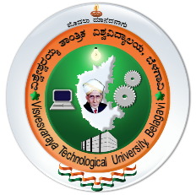**RAMAIAH INSTITUTE OF TECHNOLOGY**

(An Autonomous Institute affiliated to VTU)

MSR Nagar, MSRIT Post, Bangalore – 560054

www.msrit.edu

**2018-19**